APRIL 2020 | Fort Belvoir Golf Club
FEATURED EVENT  - 1st First Tee Time 7:30 Everyday  - 2nd FBRMGA 9:00am  - 7th FRITZMAS  - 7th LGAFB First play day  - 9th FBRMGA Spring Bash 8:30  - 12th EASTER  - 18th 6-6-6 Tournament  - 23rd - 27th Spring Maintenance  - 23rd NVMRGA 9:00  - 30th NVRMGA 9:am | 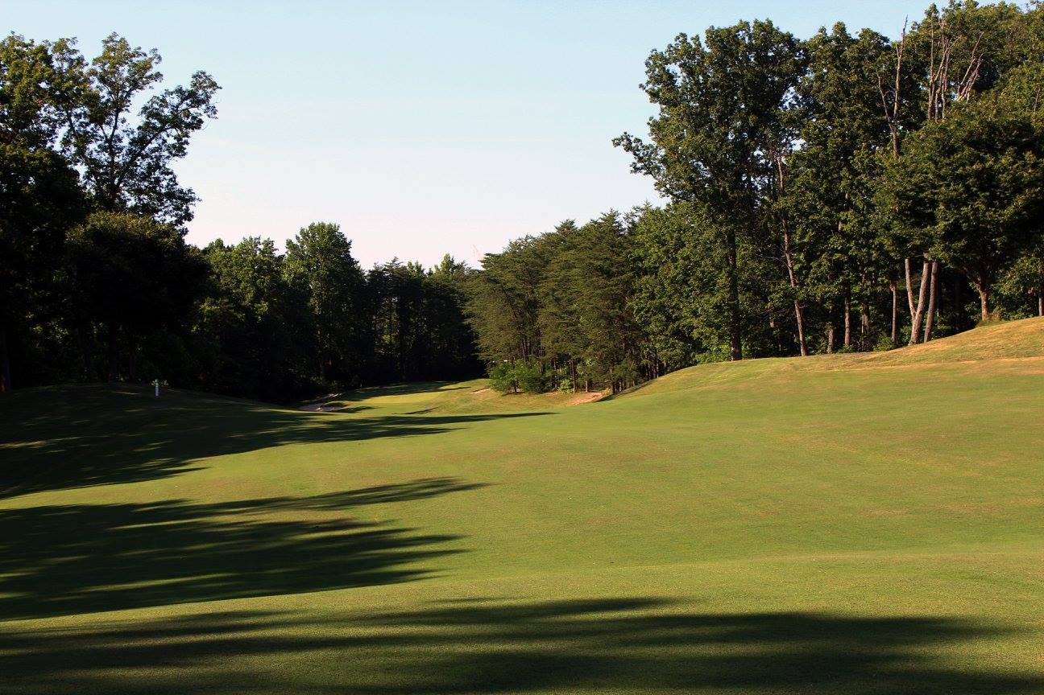
 | New Year, New Store Lay-Out!
Sunday | Monday | Tuesday | Wednesday | Thursday | Friday | Saturday
 |  |  | 1 | 2 | 3 | 4
 |  |  | NVRMGA  9am Woodlawn  56 ppl | Maintenance  Woodlawn |  | Shotgun 8am  Woodlawn
5 | 6 | 7  LGAFB  Gunston 40ppl  Gunston 9:00am  “FRITZMAS” (Fritz’s Birthday) | 8  Maintenance  Gunston | 9  FBRMGA  Gunston 40ppl  Gunston | 10 | 11  Shotgun 8am  Gunston  Military  Long Drive  1-4pm
12  EASTER | 13 | 14  LGAFB  Woodlawn 40ppl  9:00am | 15  Maintenance  Woodlawn | 16 | 17 | 18  6-6-6 tournament  9am Woodlawn  Wounded Warrior Clinics begin
19 | 20 | 21  LGAFB  Gunston 40ppl  9:00am | 22  Maintenance  Gunston | 23  NVRMGA  Gunston 56ppl  Gunston  G-8 2pm 72ppl  Gunston | 24  GFBES  Gunston 8am  72ppl  Daedalians  2pm | 25  Shotgun 8am  Gunston
26 | 27 | 28 | 29 | 30
 |  | LGAFB  Woodlawn 40ppl  9:00am | Maintenance  Woodlawn  Garrison Scramble  Woodlawn 9 holes | NVRMGA  Gunston 40ppl  Woodlawn

