AUGUST 2021 | Fort Belvoir Golf Club
FEATURED EVENT:  First Tee time 7:00 Everyday  21st- 22nd Club Championship  23rd –Sept 3rdMaitnenance (1 course open) | 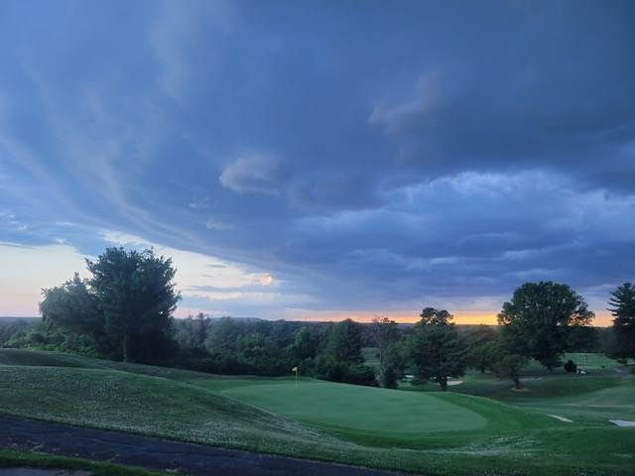
 | New Year, New Store Lay-Out!
Sunday | Monday | Tuesday | Wednesday | Thursday | Friday | Saturday
1 | 2 | 3 | 4 | 5 | 6 | 7
Cart Mandatory  Gunston |  | LGAFB  Gunston 8:00am | Maintenance  Gunston |  | MCRA  8:00amGunston  80 ppl | Shotgun  8:00am Gusnton
8 | 9 | 10 | 11 | 12 | 13 | 14
Cart Mandatory  Woodlawn | FBRMGA 8:30am shotgun  Woodlawn  45ppl | LGAFB  Member-Guest!!!!  Woodlawn 9am  60 ppl | TAAB  8:00am Woodlawn  72 ppl | NVRMGA  9:00am Woodlawn  56 players | Warrant Officer Association  8:00am  Woodlawn 72 ppl | Shotgun  8:00am Woodlawn
15 | 16 | 17 | 18 | 19 | 20 | 21
Cart Mandatory  Gunston | ARFAX Cup  Woodlawn 9:00am  72 ppl | LGAFB  Gunston 8:00am | Maintenance  Gunston | NVRMGA  Gunston 9:00am | Aldergate united  8:00am Gunston  72 ppl | Club Championship 8:00am Gunston  72 ppl
22 | 23 | 24 | 25 | 26 | 27 | 28
Club Championship 8:00am Woodlawn 72ppl | Maintenance  One course open | Maintenance  One course open | Maintenance  One course open | Maintenance  One course open | Maintenance  One course open | Shotgun  8:00am Woodlawn
29 | 30 | 31
Cart Mandatory  Gunston | Maintenance  One course open | Maintenance  One course open

